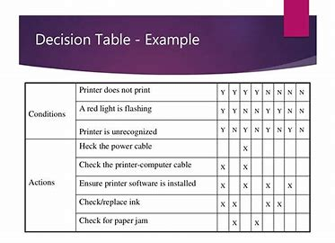

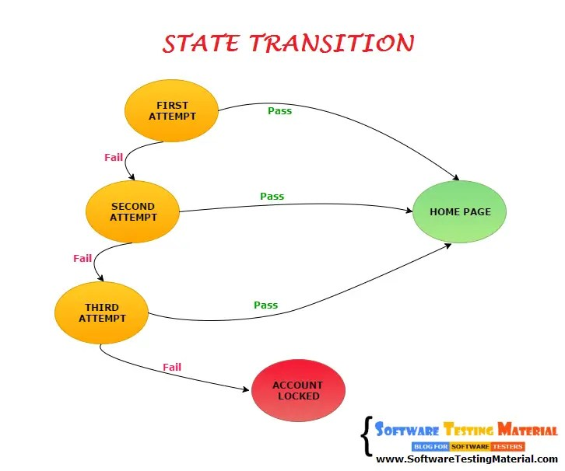

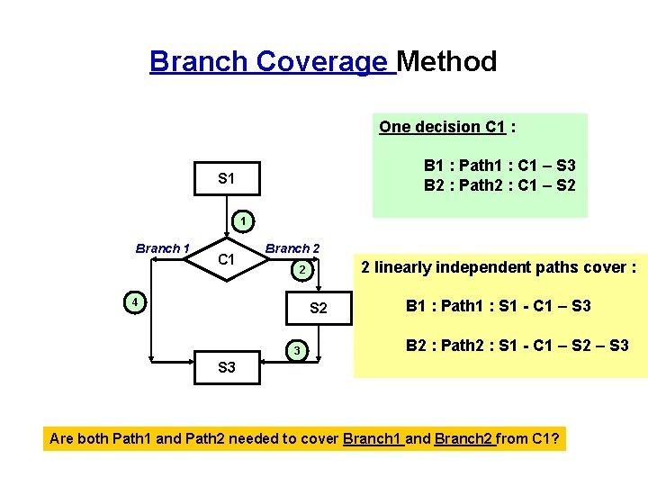

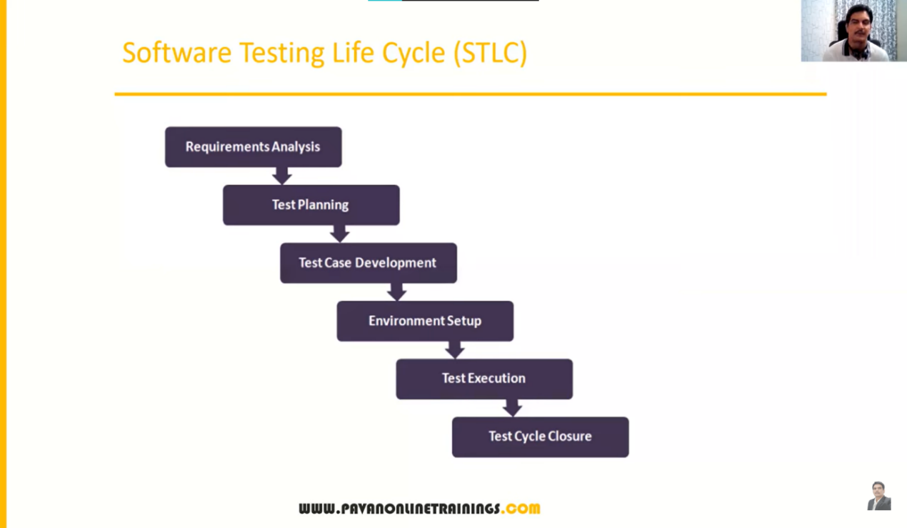

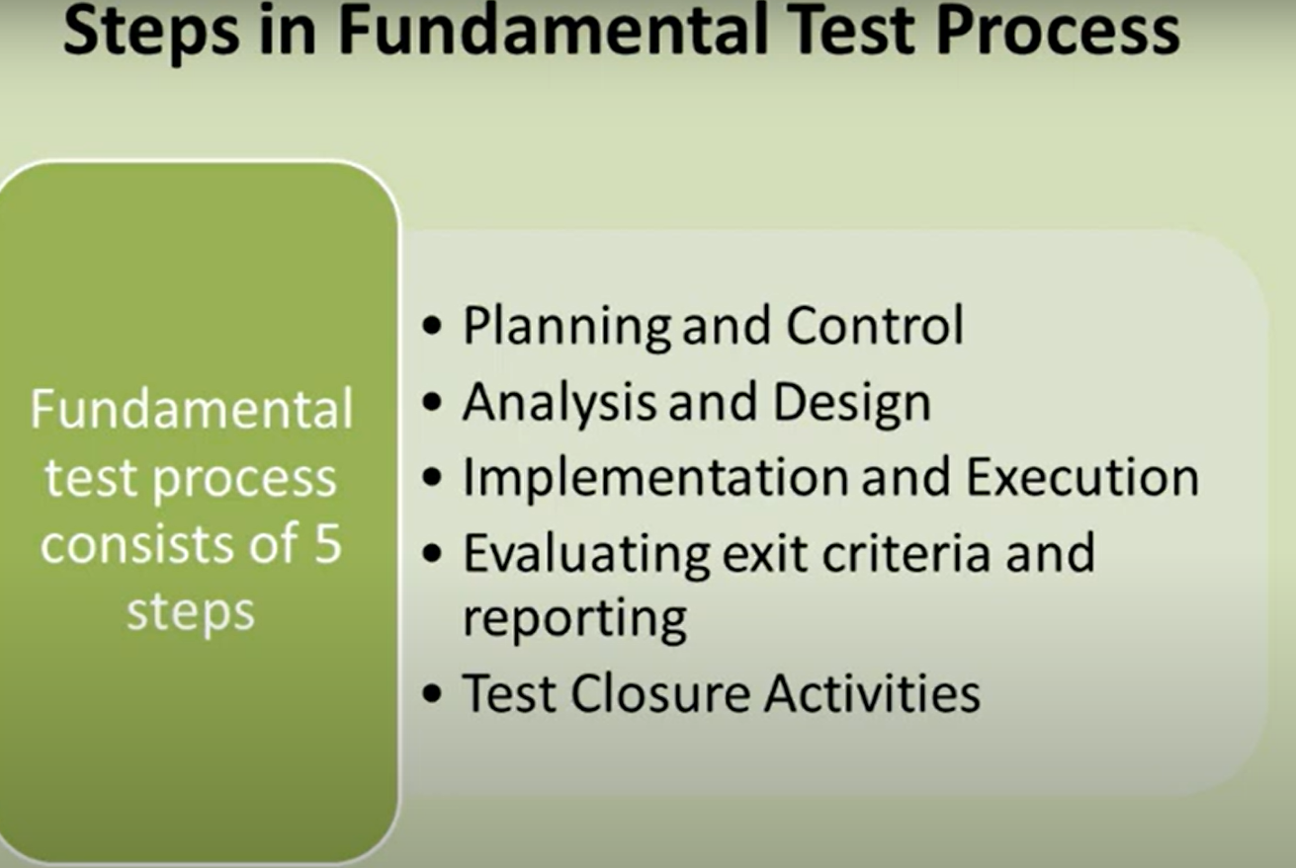

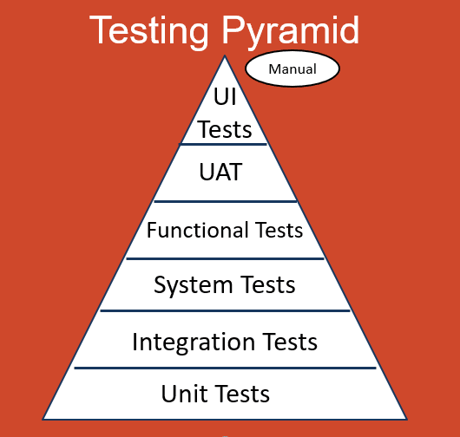

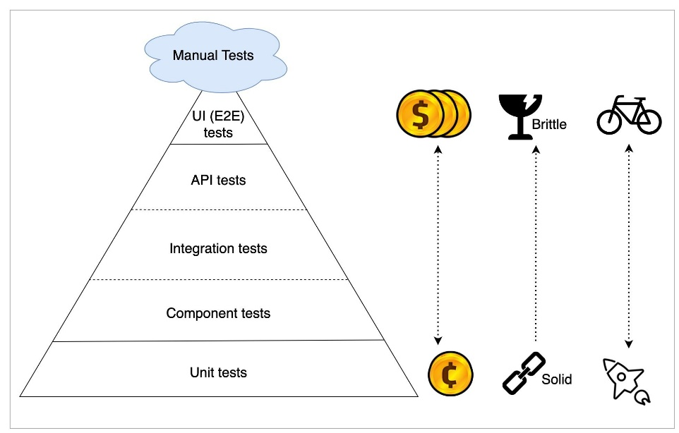

<https://www.geeksforgeeks.org/software-testing-life-cycle-stlc/>

System testing can include a variety of test types such as load testing, stress testing, performance testing, usability testing, regression testing, and security testing, depending on the specific needs and risks associated with the system.

System testing involves both functional and non-functional testing

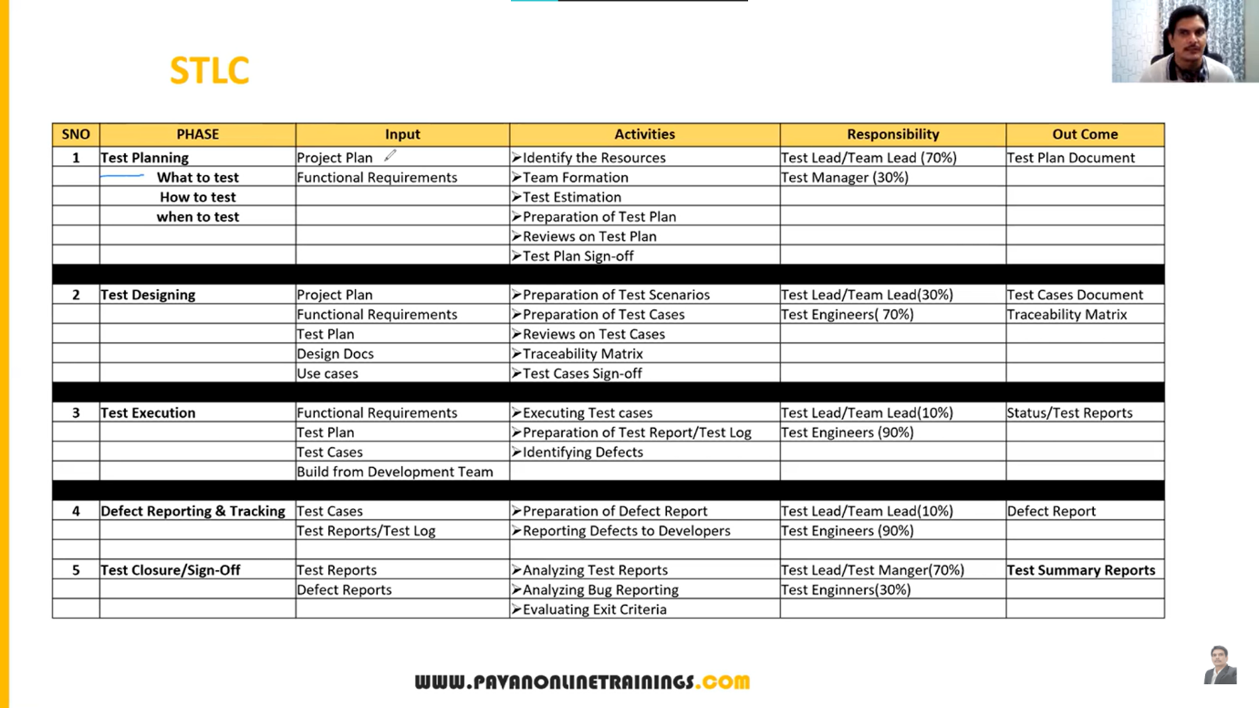

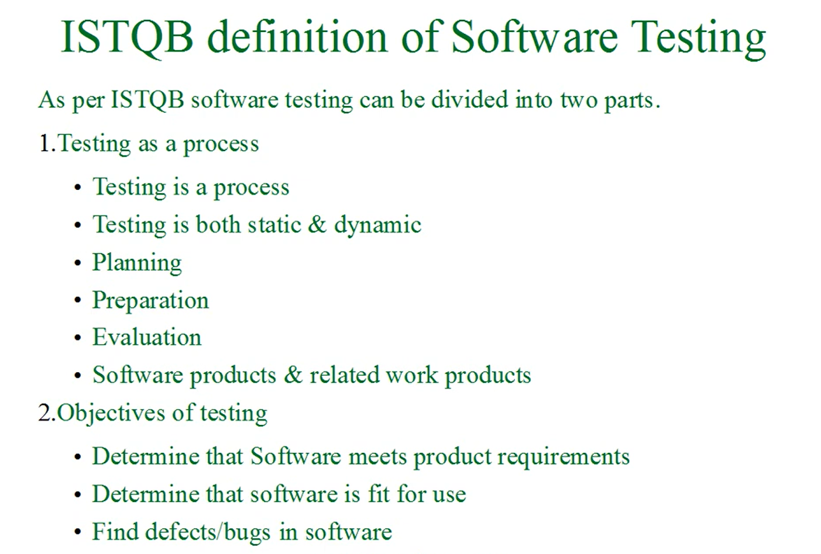

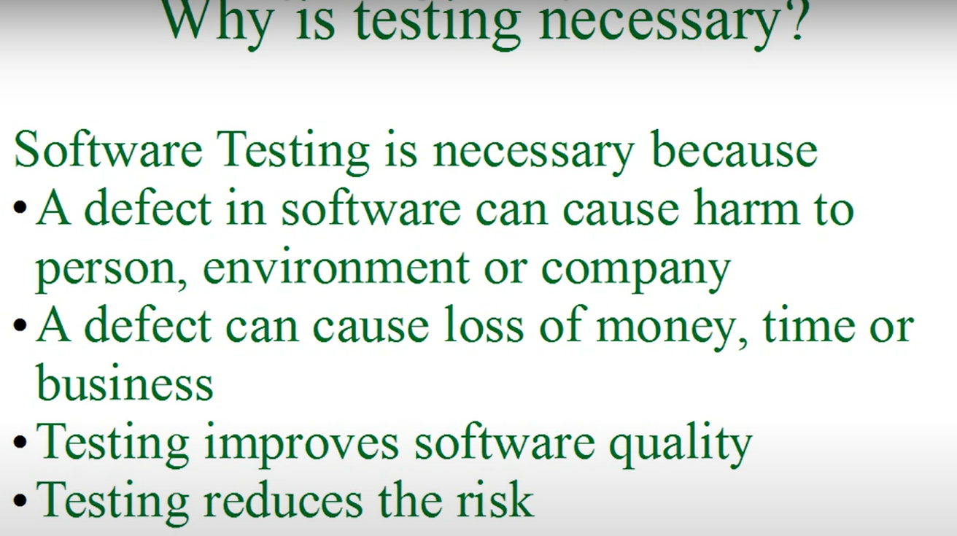

Defects causes due to

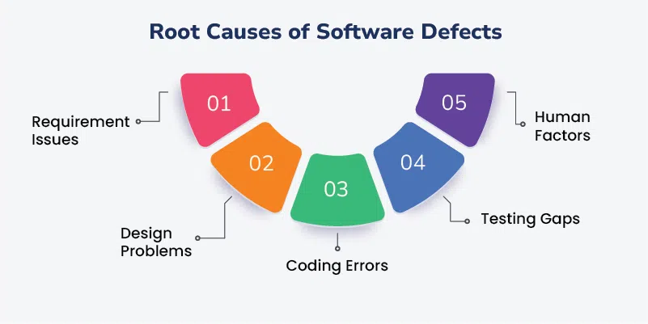

Security flaws, Time pressure, System errors

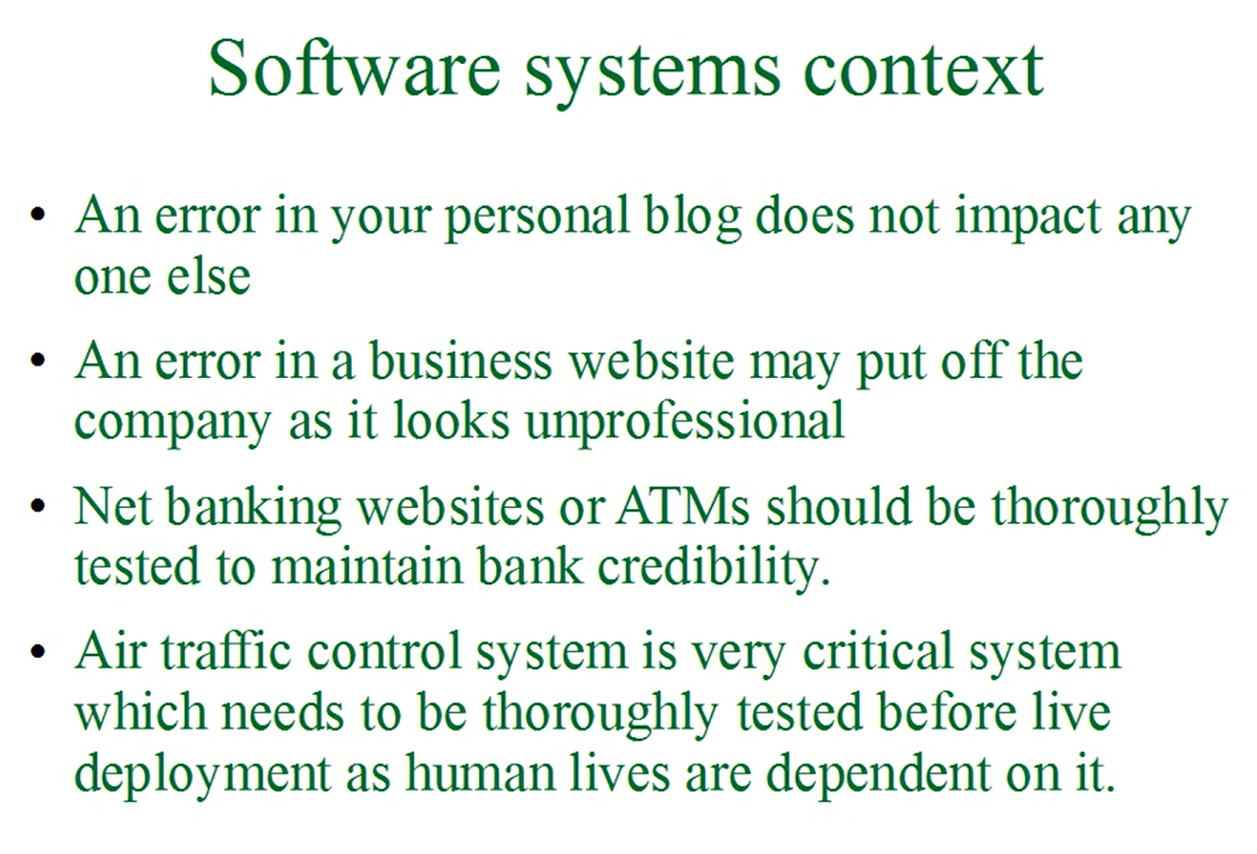

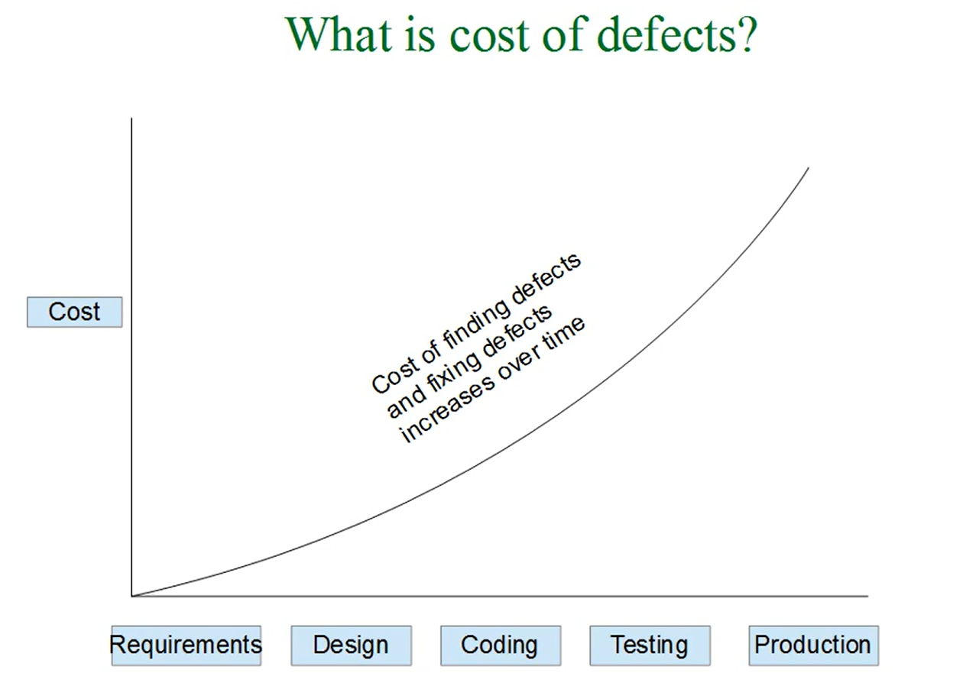

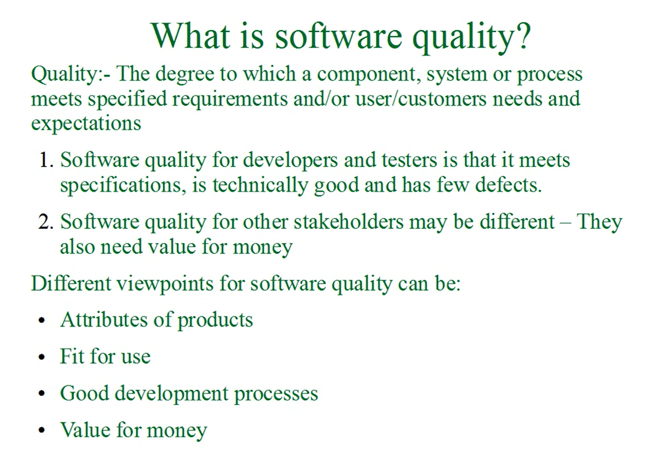

Software Quality- meets specifications, fit for use, value for money

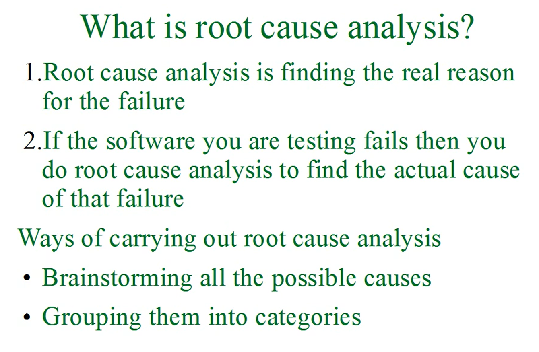

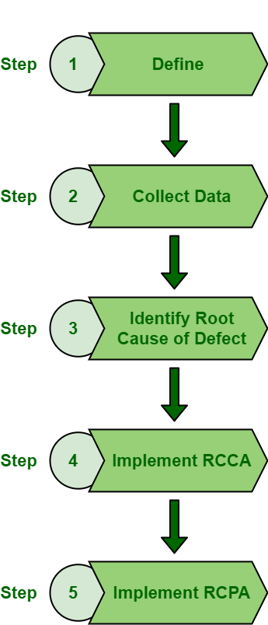

issue

RCCA -Root Cause Corrective Action

RCPA – Root Cause Preventive Action

Causes: are fundamental reasons for the defect or incident

Symptioms : effect of the causes

**Fishbone diagram :**

Resembling a fish skeleton, this visual tool provides a graphic representation of the factors that could be contributing to a problem, with the head representing the issue and the bones representing the categories of potential causes. It is particularly effective at fostering collaboration among teams and can help lead to a more comprehensive understanding of the problem.

5 WHYs

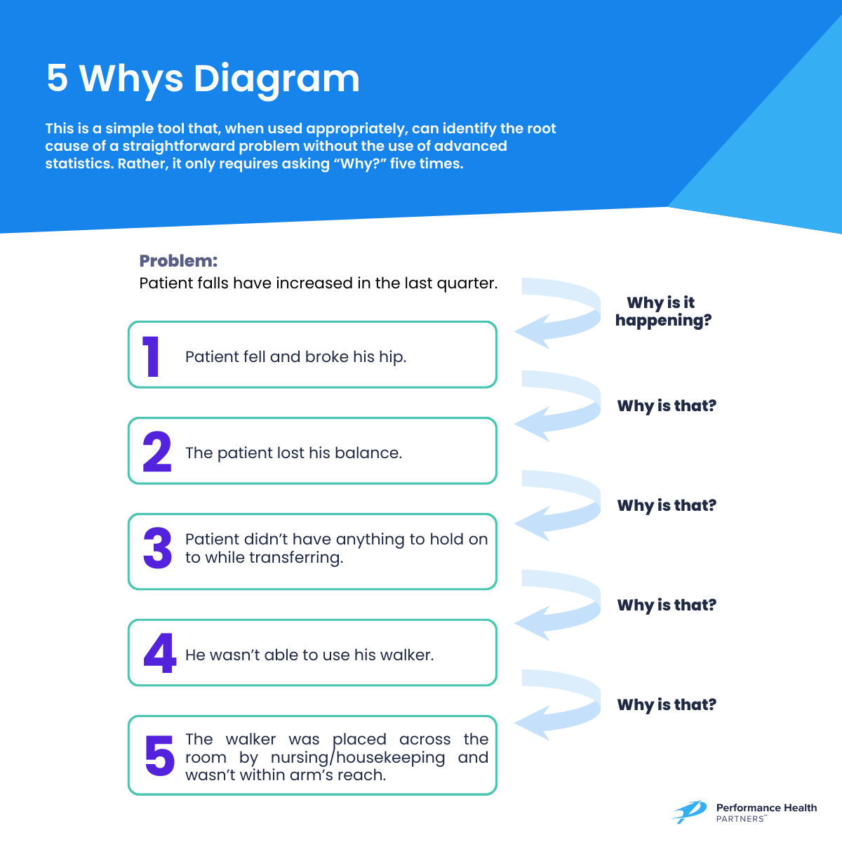

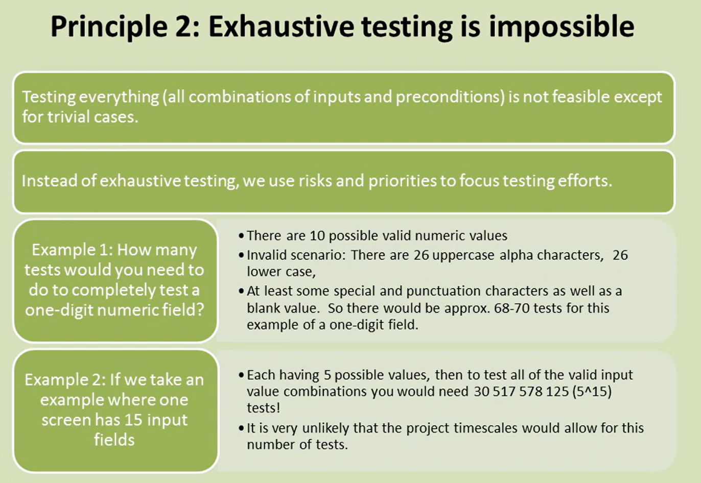

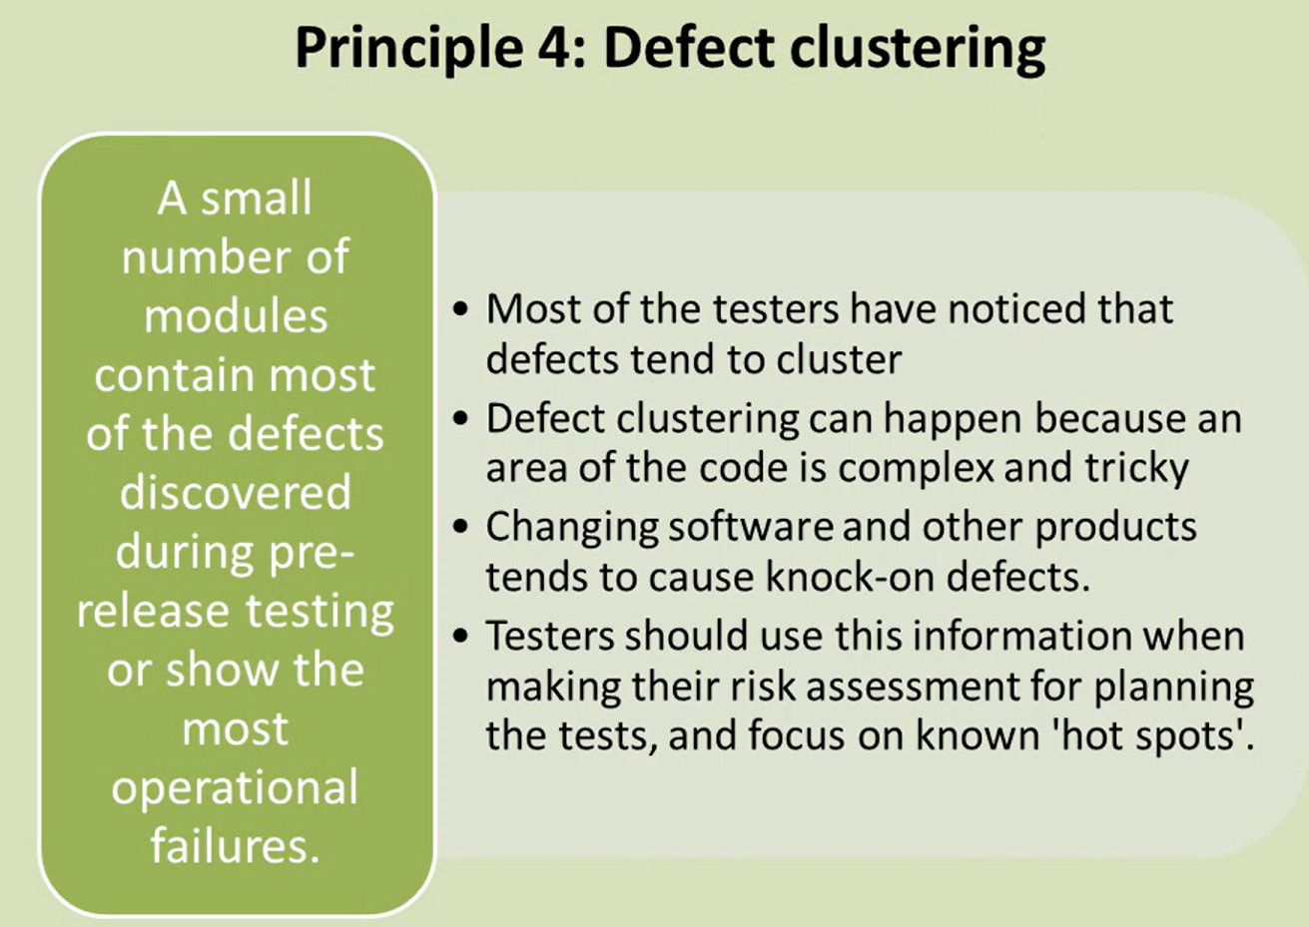

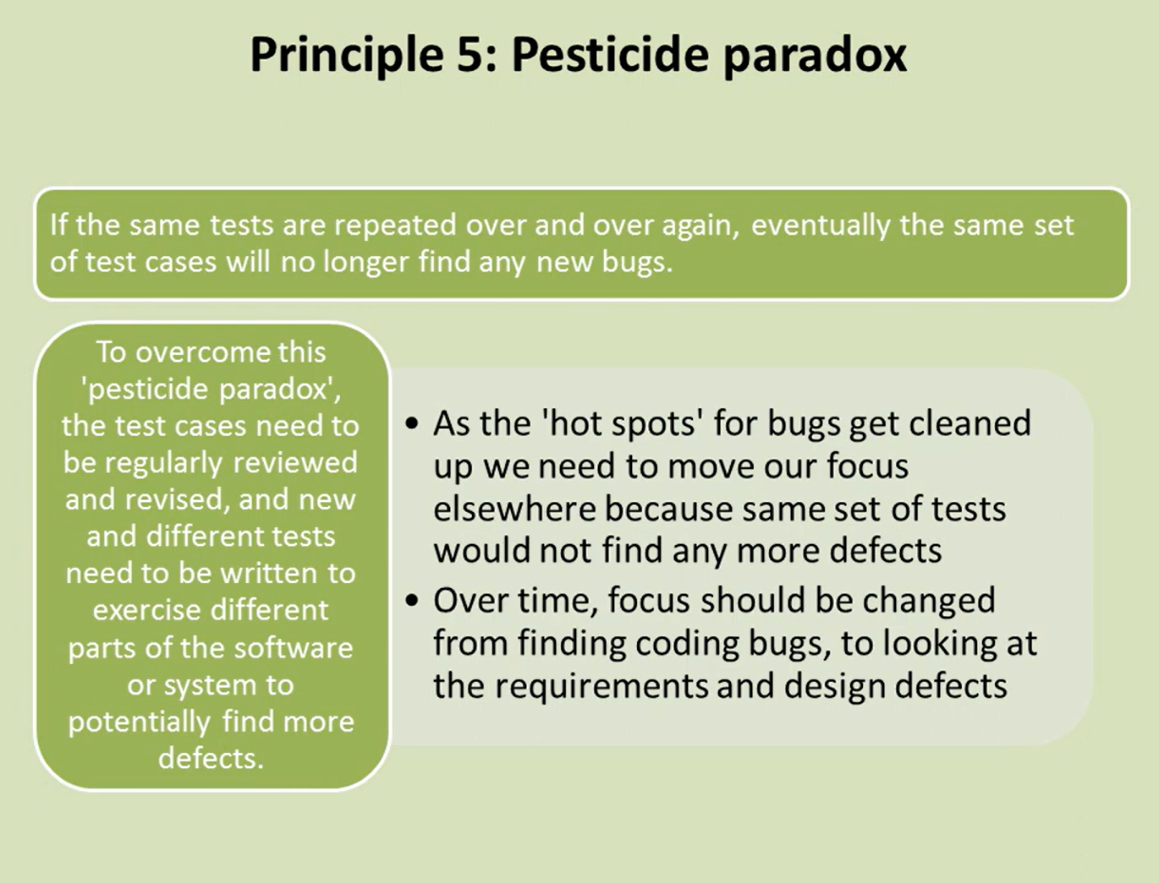

Test plan:

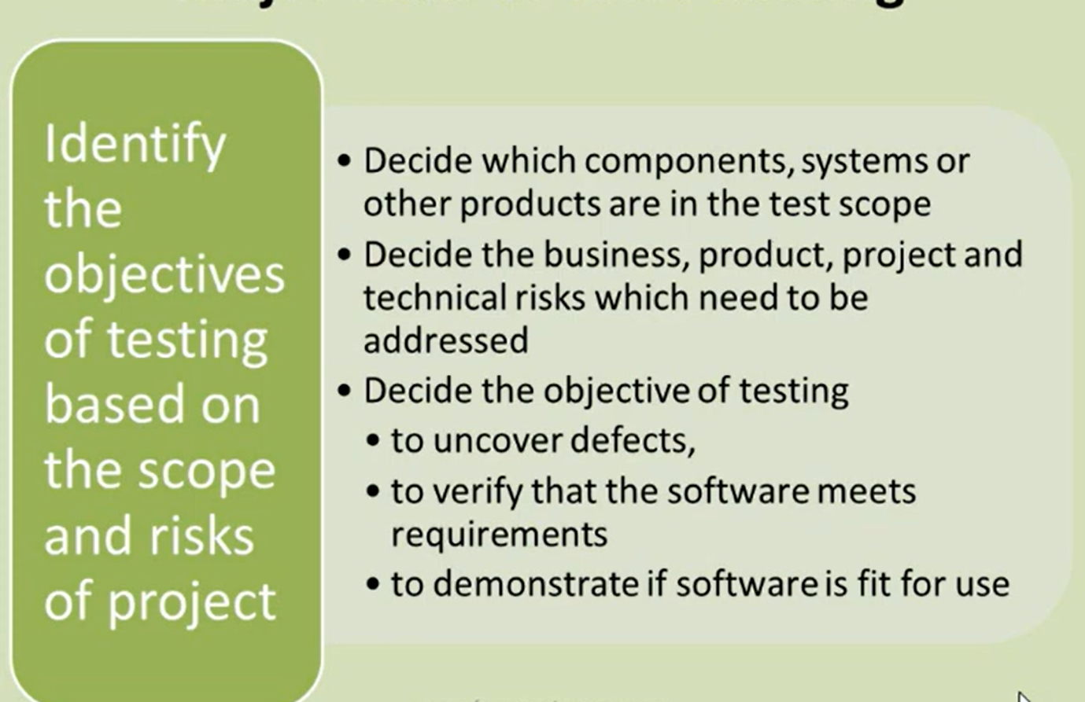

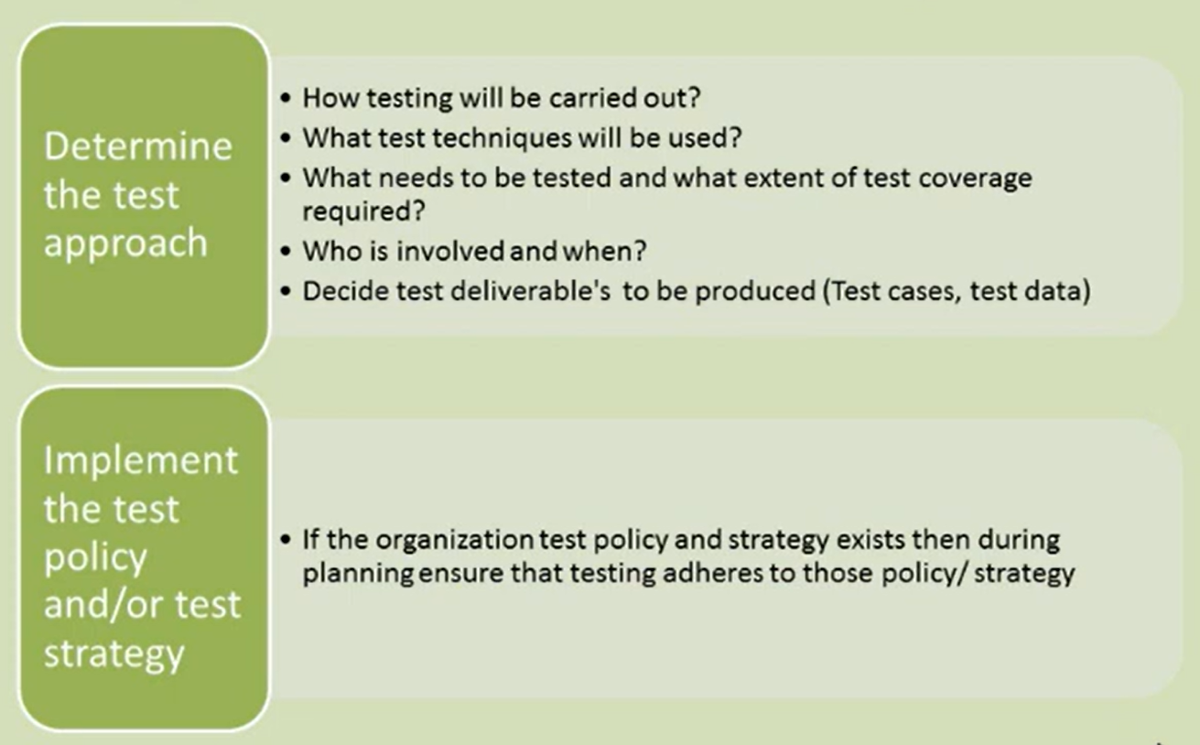

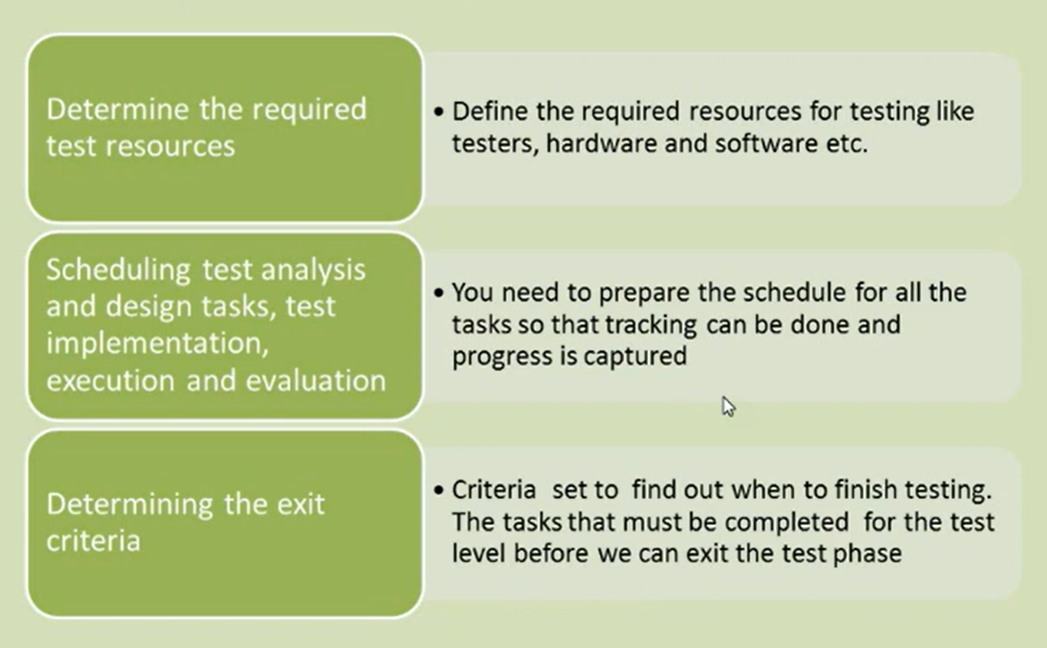

Test Control:

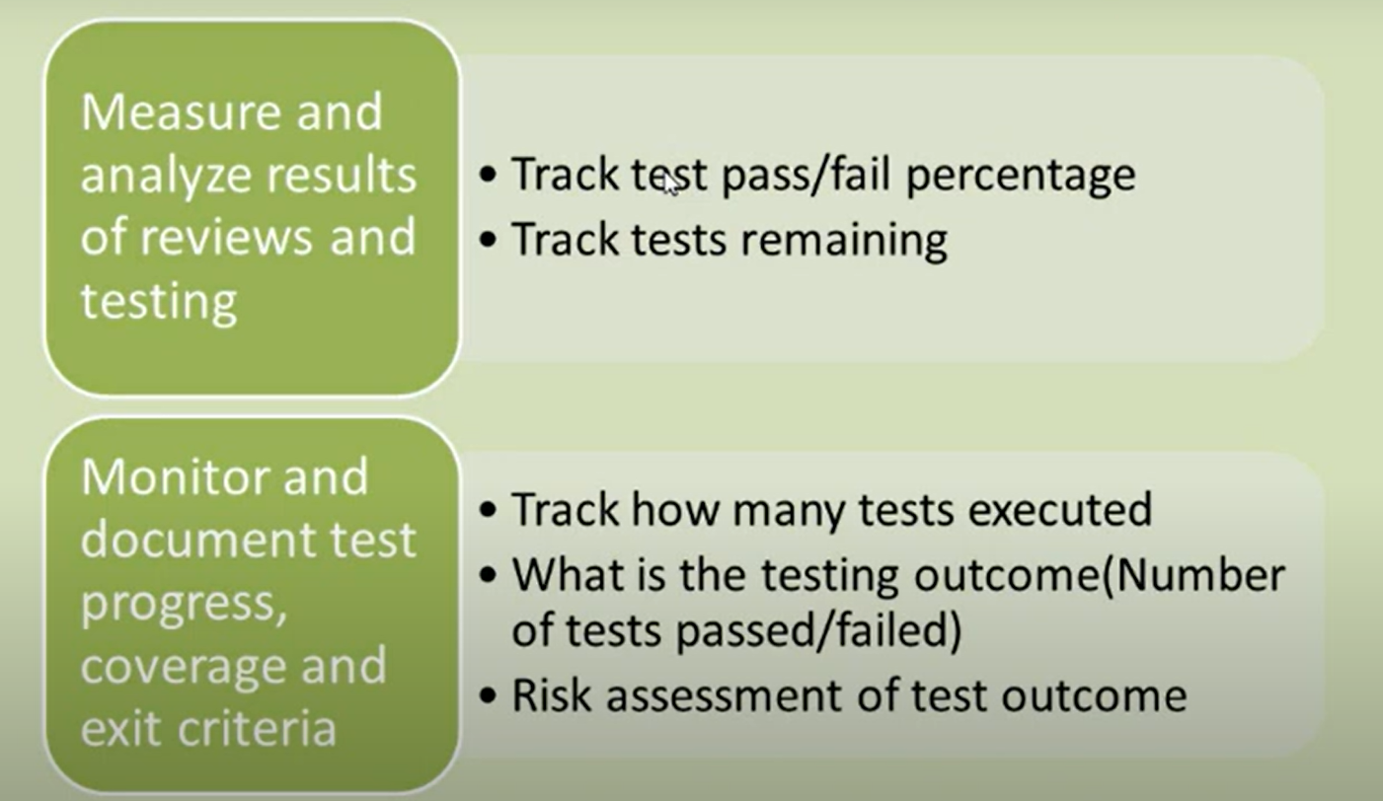

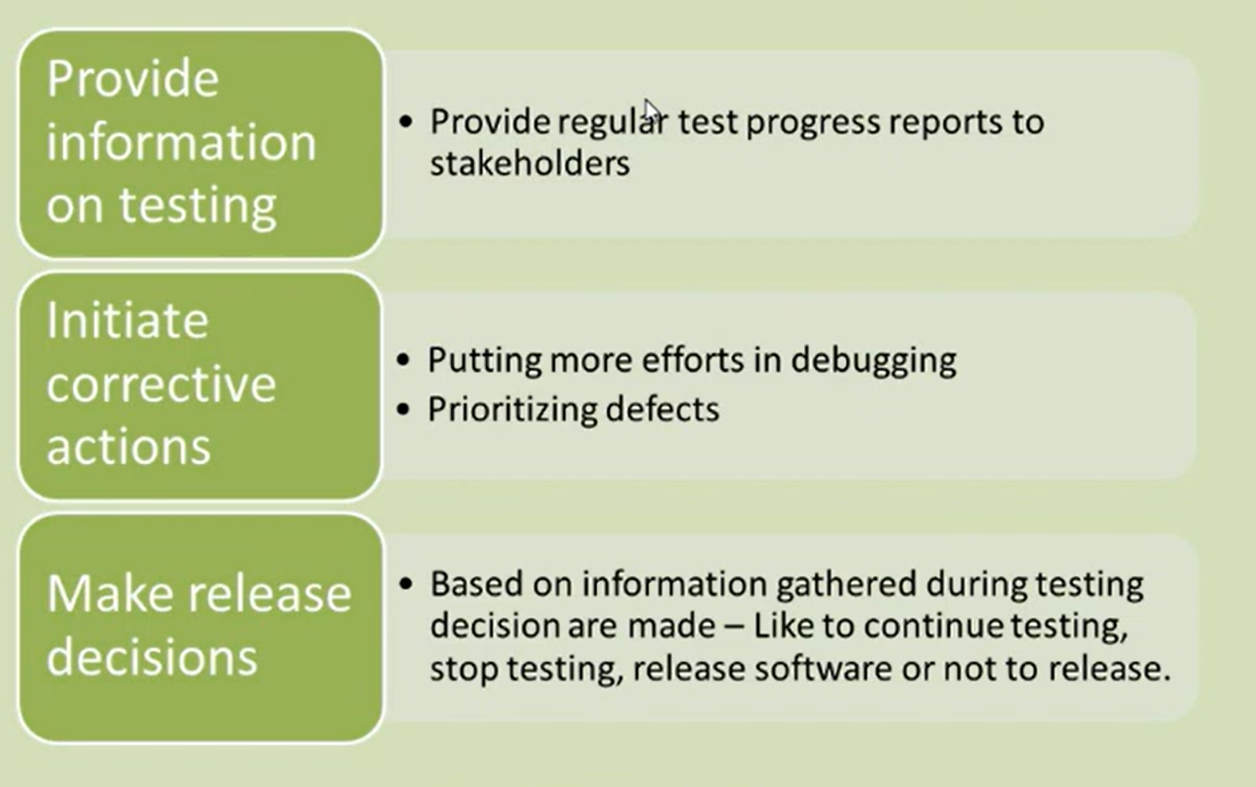

Test Analysis and Design:  
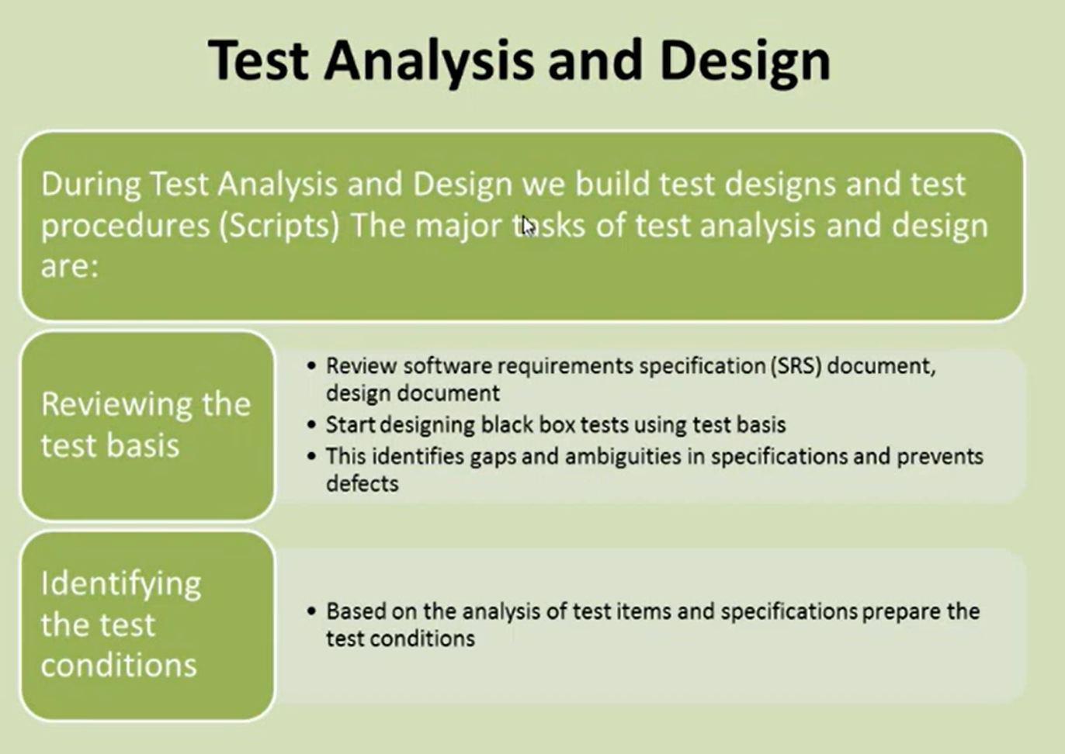

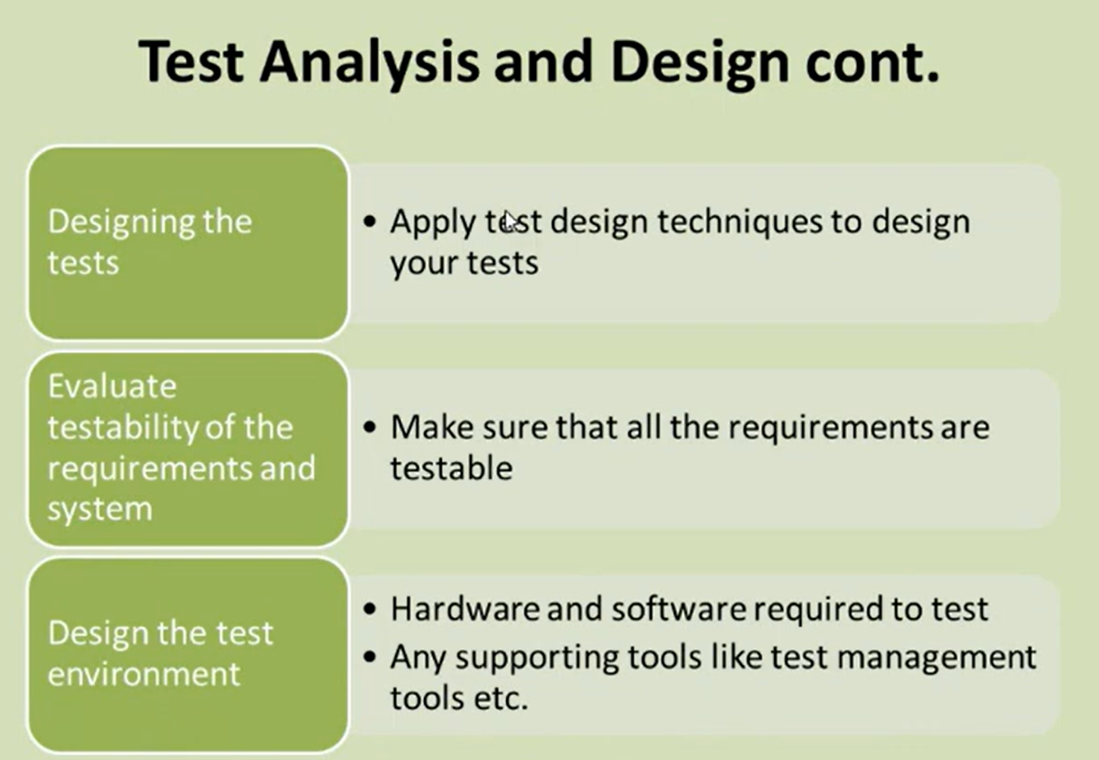

Test Implementation and Execution:  
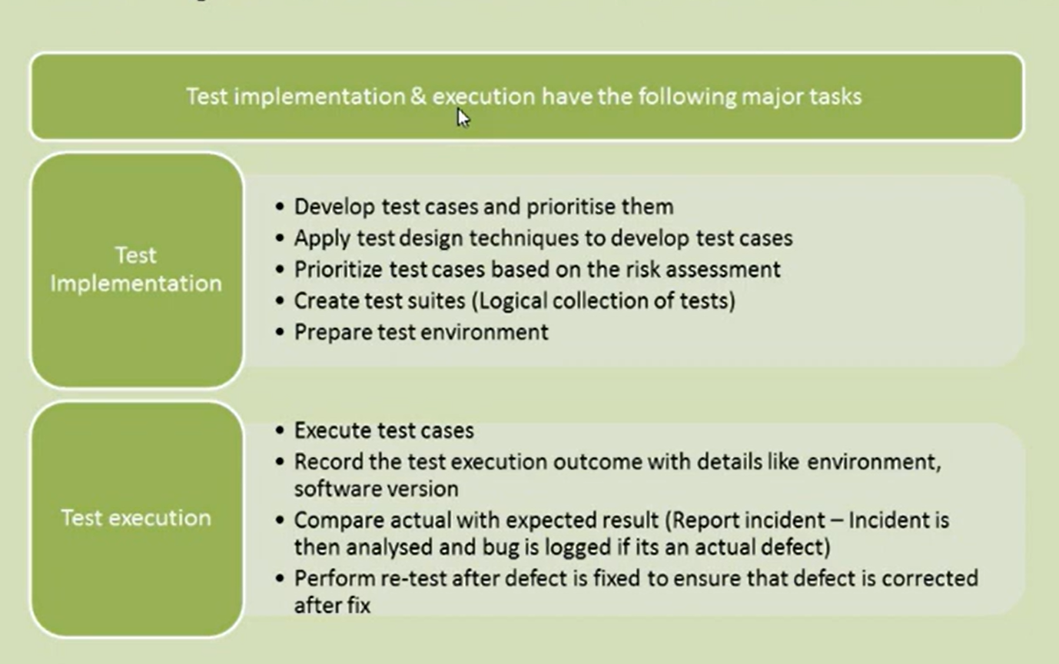

1. **Test Design:**
   * **Goal:** The primary goal of Test Design is to define and plan what needs to be tested and how testing will be performed.
   * **Activities:** This phase involves creating test cases and test scenarios based on the requirements and specifications of the software application. Test designers use techniques like boundary value analysis, equivalence partitioning, decision table testing, state transition diagrams, and use case testing to determine the expected outcomes. This phase also includes the design of test scripts, identification of test data, and outlining the test environment setup.
   * **Output:** The output of this phase is a set of structured test cases and test scripts that cover various aspects of the software functionality.
2. **Test Implementation:**
   * **Goal:** The objective of Test Implementation is to prepare for execution by setting up the testing environment and arranging the designed test cases into test suites.
   * **Activities:** This phase involves arranging the test cases, writing test scripts (if automated), setting up the test environment, creating test data, and reviewing or reworking the initial test designs where necessary. Test cases may also be prioritized, and dependencies between test cases are defined.
   * **Output:** The major outputs are a ready and verifiable test environment, and test suites that are ready to be executed.
3. **Test Execution:**
   * **Goal:** The goal of Test Execution is to run or execute the test cases prepared and see if the software behaves as expected.
   * **Activities:** During this phase, testers execute the test cases on the testing environment and document the results, which include logging of any faults or bugs found in the product. Testers also monitor the performance and behavior of the software under different conditions.
   * **Output:** The outputs include detailed test results that document each test case's success or failure and issue reports detailing any defects identified during testing.

Evaluating Exit criteria and Reporting:  
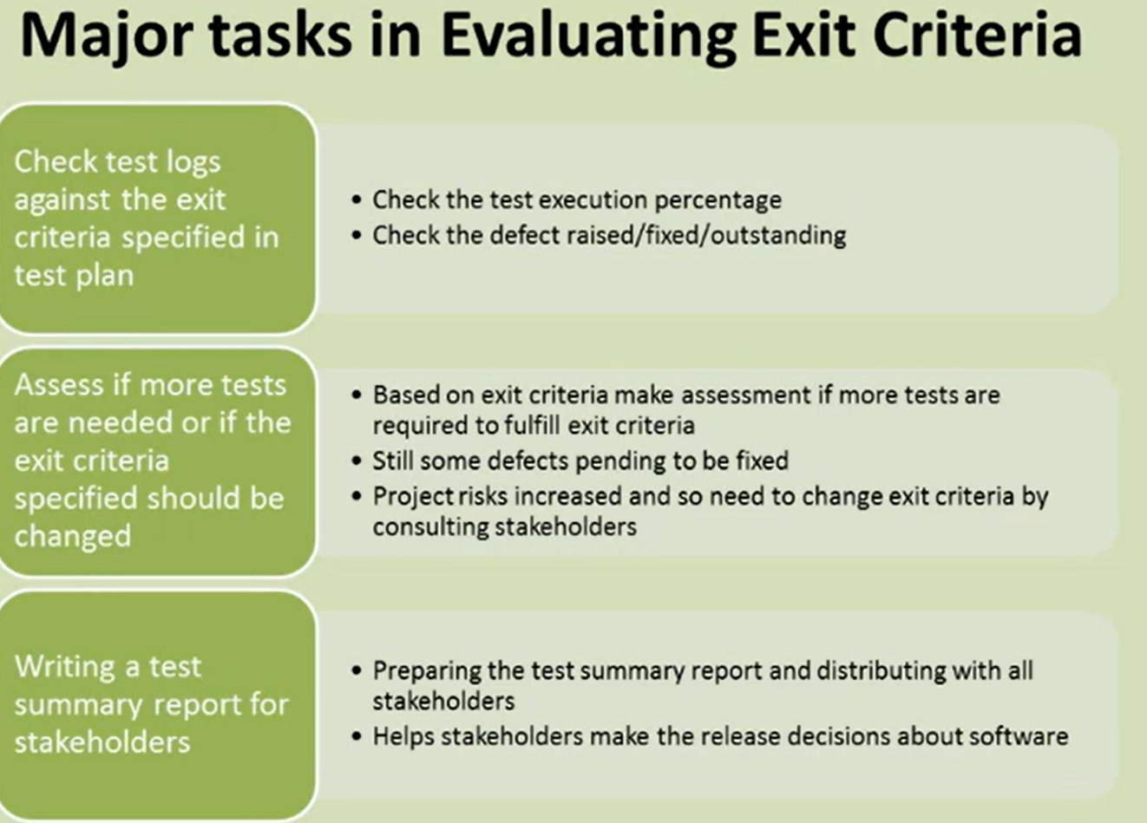

Test closure:  
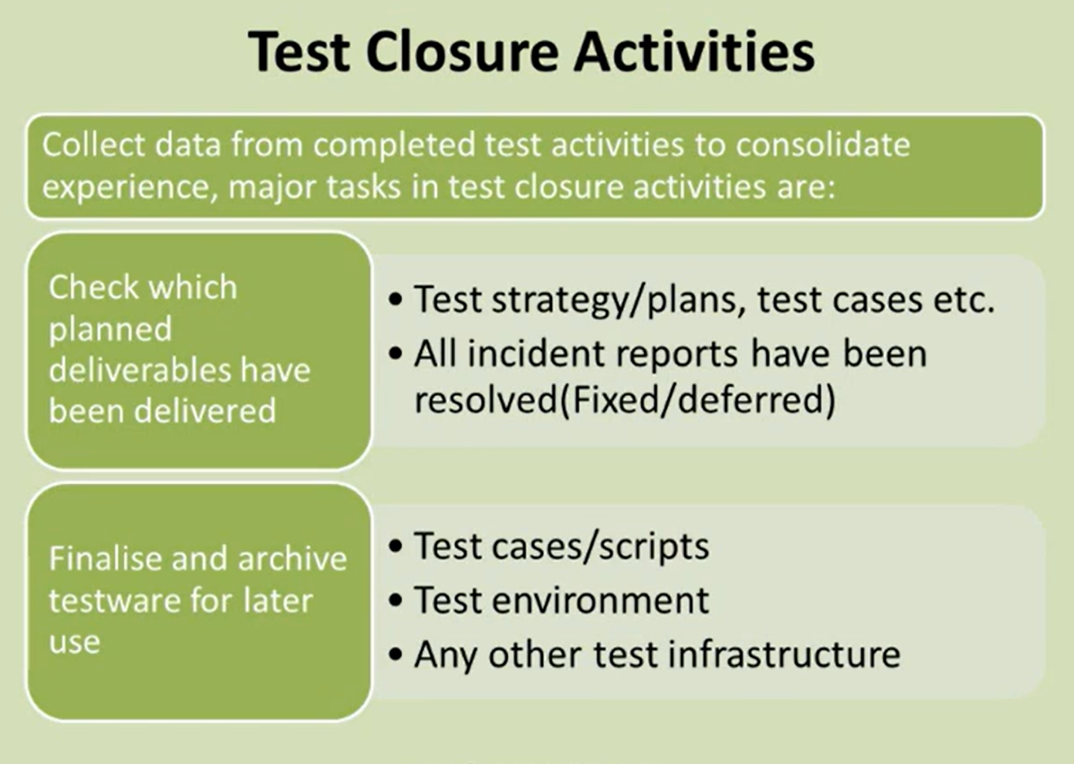

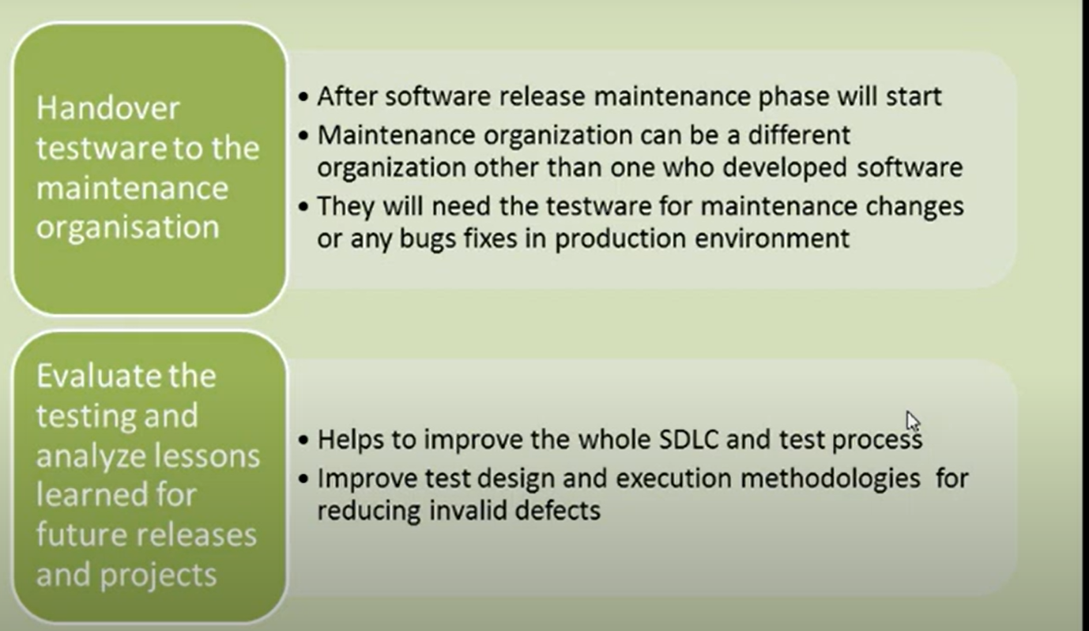

RTM:

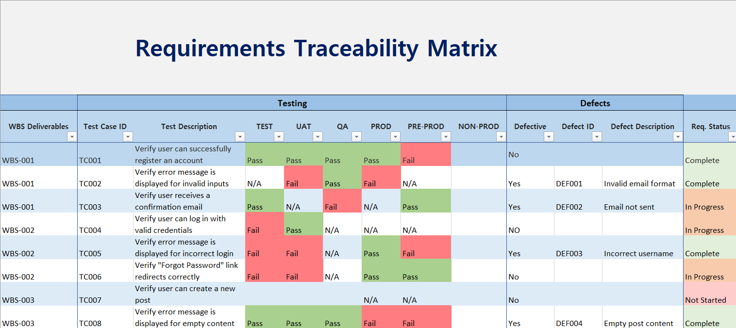

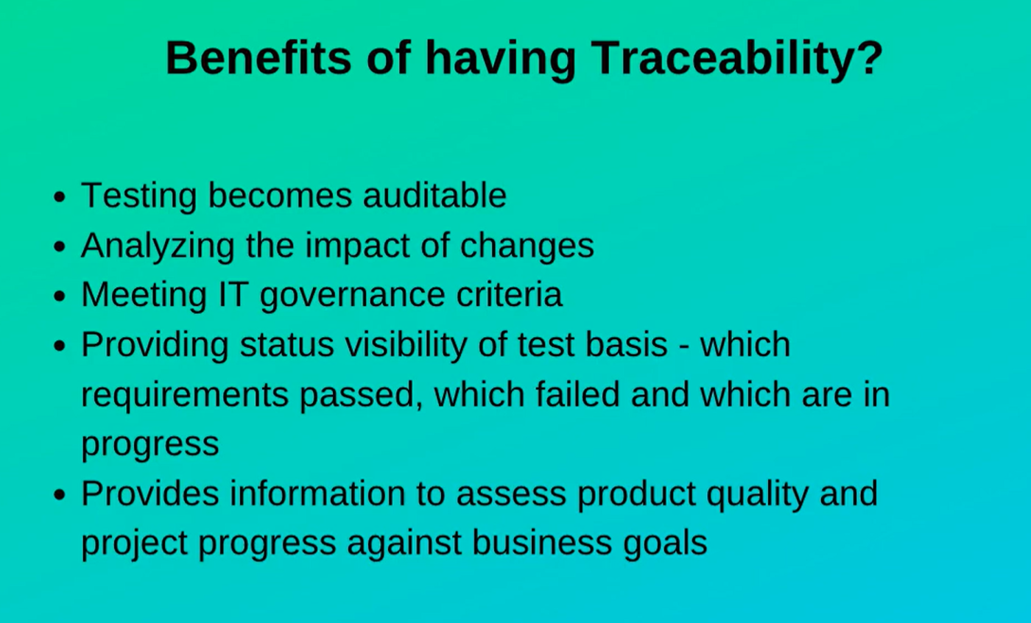

**Independent testing** in software testing is a process where the testing of a software product is carried out by a specialized team or a third-party organization that is not involved in the development of the software

Mindset varies between developers and testers

Developers – try to build the software

Testers – try to break the software

